ATOC5860 – Application Lab #5
Filtering Timeseries
Spring 2022

Notebook #1 – ATOC5860_applicationlab5
ATOC5860_applicationlab5_check_python_convolution.ipynb

LEARNING GOAL
1) Understand what is happening “under the hood” in different python functions that are used to smooth data in the time domain. Use this notebook to understand the different python functions that can be used to smooth data in the time domain. Compare with a “by hand” convolution function. Look at your data by printing its shape and also values. Understand what the python function is doing, especially how it is treating edge effects.
- A 1-1-1 filter is applied, but for the first two values, there isn’t a full three values to use in the filtering. Therefore, the first two values will be skewed. If you want to keep the ends of your data, it might be helpful to pad the ends and then only keep the values you want to use for analysis.
- Using np.convolve with the default setting `full` returns the same results as when we applied a 1-1-1 filter which is using an array of 1/3’s.
- Using `same` gets rid of the two end values, but includes 2, which has one overlap.
- Using `valid` gets rid of the first two end values, which don’t include all three overlap values.

Notebook #2 – Filtering Synthetic Data
ATOC5860_applicationlab5_synthetic_data_with_filters.ipynb

LEARNING GOALS:
1) Apply both non-recursive and recursive filters to a synthetic dataset
2) Contrast the influence of applying different non-recursive filters including the 1-2-1 filter, 1-1-1 filter, the 1-1-1-1-1 filter, and the Lanczos filter.
3) Investigate the influence of changing the window and cutoff on Lanczos smoothing.

DATA and UNDERLYING SCIENCE:
In this notebook, you analyze a timeseries with known properties. You will apply filters of different types and assess their influence on the resulting filtered dataset.

Questions to guide your analysis of Notebook #2:

1) Create a red noise timeseries with oscillations. Plot your synthetic data – Look at your data!! Look at the underlying equation. What type of frequencies might you expect to be able to remove with filtering?
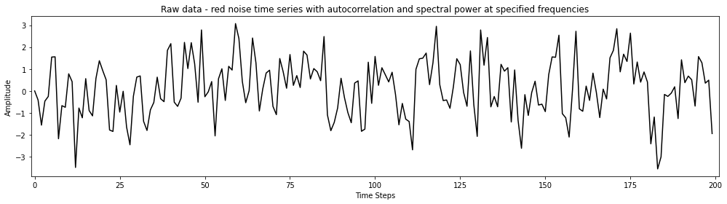
This is a red noise time series with oscillations and the cosine pattern is visible in the data, so I expect to be able to remove either high or low anomalies. Since there are frequencies oscillating every 52 and 100 times out of 256, I expect there to be anomalies when the two occur at around the same time. Alternatively, we can remove the two frequencies specified.

2) Apply non-recursive filters in the time domain (i.e., apply a moving average to the original data) to reduce power at high frequencies. Compare the filtered time series with the original data (top plot). Look at the moving window weights (bottom plot). You are using the function “filtfilt” from scipy.signal, which applies both a forward and a backward running average. Try different filter types – What is the influence of the length of the smoothing window or weighted average that is applied (e.g., 1-1-1 filter vs. 1-1-1-1-1 filter)? What is the influence of the amplitude of the smoothing window or the weighted average that is applied (e.g., 1-1-1 filter vs. 1-2-1 filter)? Tinker with different filters and see what the impact is on the filtering that you obtain.

Applying a non-recursive filter in the time dimension by 1-2-1 smooths the raw data and producing the following plot. As expected, the moving average that we apply is the weights.
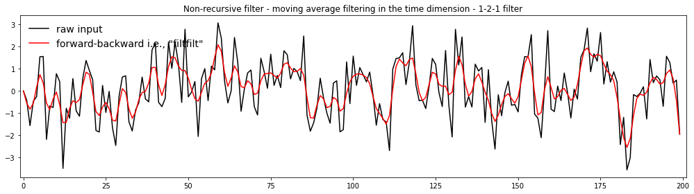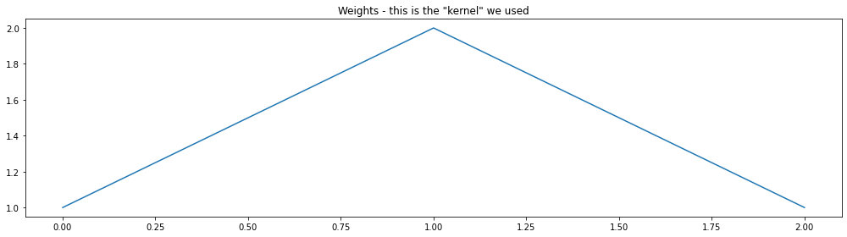
Applying a non-recursive moving average filter in the time dimension by 1-1-1 smooths the raw data and produces the following weight plot. The weight plot is consistent at 1 because we’re applying the same weight for the entire dataset. The filtered timeseries looks relatively the same as the 1-2-1 filter, but with less extreme peaks.
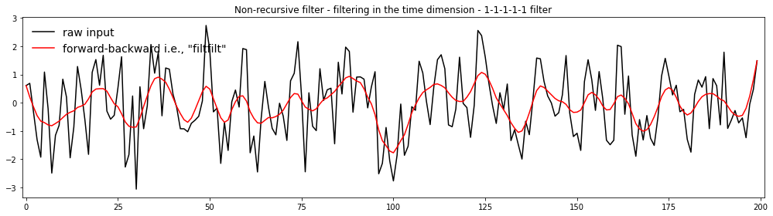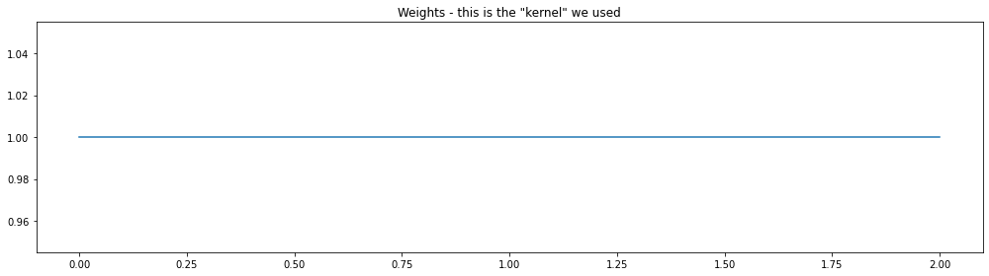
Similar to applying the 1-1-1 filter, applying a non-recursive moving average filter in the time dimension by 1-1-1-1-1 smooths the raw data more than the 1-1-1 filter. The weights plot is similar to the 1-1-1 weights plot because a constant filter is applied within the window. It produces a similar weight plot as the 1-1-1 filter because again, the same filter is applied for all of the data. It seems to reduce the amplitude of the data, which I would expect because it is smoothed.
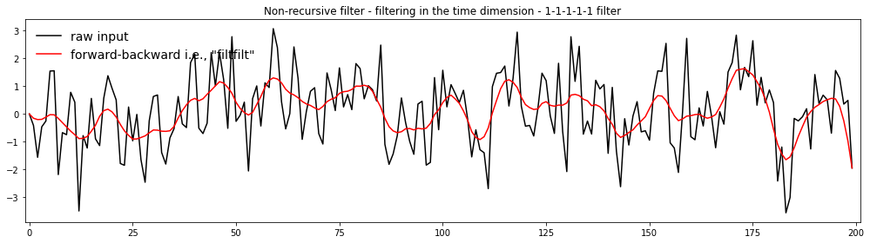
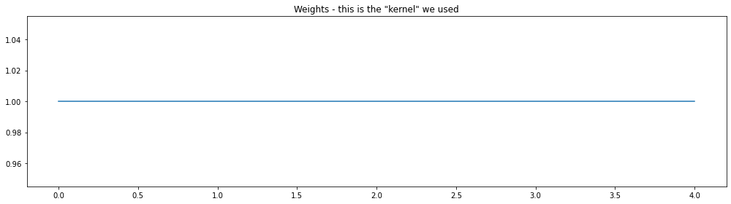
3) Apply a Lanczos filter to remove high frequency noise (i.e., to smooth the data). What is the influence of increasing/decreasing the window length on the smoothing and the response function (Moving Window Weights) in the Lanczos filter? What is the influence of increasing/decreasing the cutoff on the smoothing and the response function?

With a window length of 25, the filtered data is much smoother, and the response function has signals on either side below 0 Increasing the window.
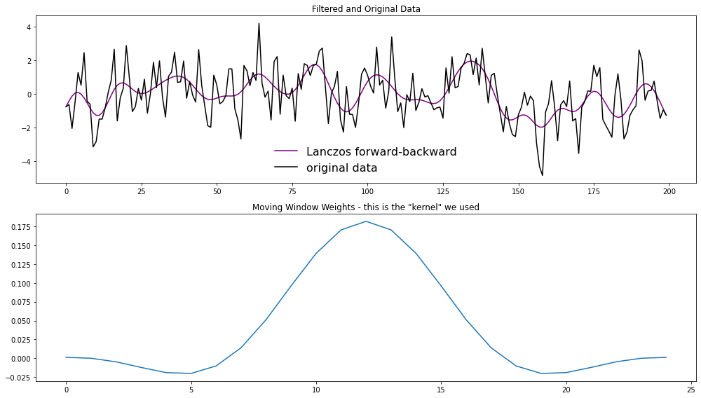
With a window length of 50, the data is smoother, but the response function has a larger signal on either tail.
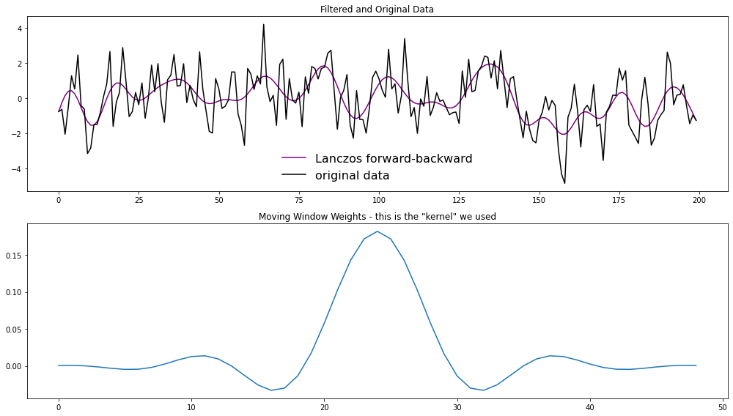
If you decrease to 5, you get less smoothing.

4) Apply a Butterworth filter, a recursive filter. Compare the response function (Moving Window Weights) with the non-recursive filters analyzed above.
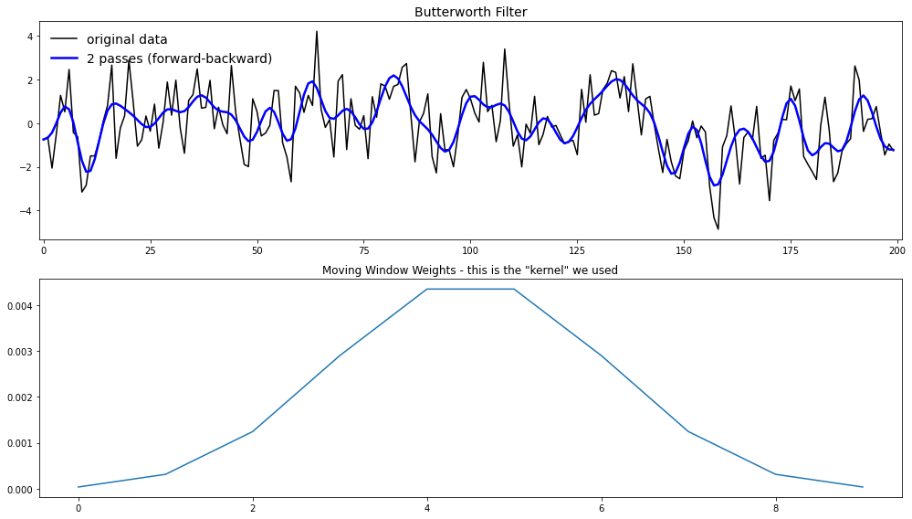
The data has been smoothed less than when we used the Lanczos filter, but the response function has decreasing weight at the edges of the boundary, so there isn’t unintentional signal created at the tails.

Notebook #3 – Filtering ENSO data
ATOC5860_applicationlab5_mrbutterworth_example.ipynb

LEARNING GOALS:
1) Assess the influence of filtering on data in both the time domain (i.e., in time series plots) and the spectral domain (i.e., in plots of the power spectra).
2) Apply a Butterworth filter to remove power of specific frequencies from a time series.
3) Contrast the influence of differing window weights on the filtered dataset both in the time domain and the spectral domain.
4) Calculate the response function using the Convolution Theorem.
5) Assess why the python function filtfilt is filtering twice.

DATA and UNDERLYING SCIENCE:
In this notebook, you analyze monthly sea surface temperature anomalies in the Nino3.4 region from the Community Earth System (CESM) Large Ensemble project fully coupled 1850 control run (http://www.cesm.ucar.edu/projects/community-projects/LENS/). A reminder that an pre-industrial control run has perpetual 1850 conditions (i.e., they have constant 1850 climate). The file containing the data is in netcdf4 format: CESM1_LENS_Coupled_Control.cvdp_data.401-2200.nc

Does this all look and sound really familiar? It should!! This dataset is the same one you analyzed in Homework #4.

Questions to guide your analysis of Notebook #3:

1) Look at your data! Read in your data and Make a plot of your data. Make sure your data are anomalies (i.e., the mean has been removed). Look at your data. Do you see variance at frequencies that you might be able to remove?
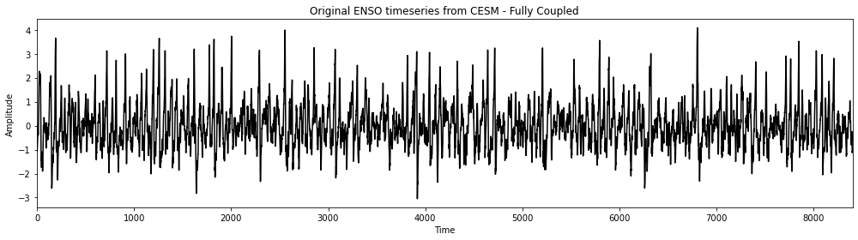
The data are anomalies. It looks like there are frequencies that we could remove every 70-100 months.

2) Calculate the power spectrum of your original data. Calculate the power spectra of the Nino3.4 SST index (variable called “nino34”) in the fully coupled model 1850 control run. Apply the analysis to the first 700 years of the run. Use Welch’s method (WOSA!) with a Hanning window and a window length of 50 years. Make a plot of normalized spectral power vs. frequency. Where is their power that you might be able to remove with filtering?
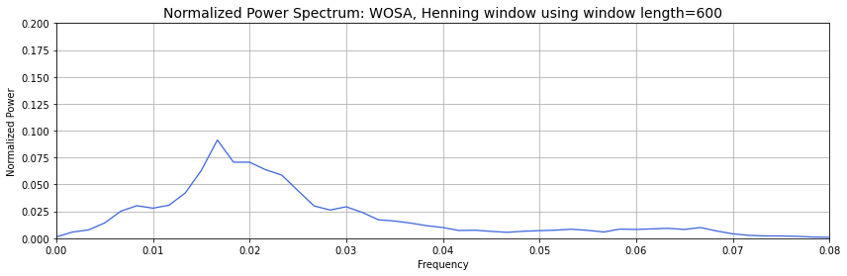
There is a lot of power at frequencies between 0.016 and 0.03, which is between 62.5 months^{–1} and 33 months^{–1}, respectively. The window length is 600 months.

3) Apply a Butterworth Filter. Use a Butterworth filter to remove all spectral power at frequencies greater than 0.04 per month (i.e., less than 2 year). Use an order 1 Butterworth filter (N=1, 1 weight). Replot the original data and the filtered data. Calculate the power spectra of your filtered data. Assess the influence of your filtering in both in time domain (i.e., by comparing the original data time series and filtered time series data) and the frequency domain (i.e., by comparing the power spectrum of the original data and the power spectrum of the filtered data). Look at the response function of the filter in spectral domain using the convolution theorem. Well that was pretty boring… we still have most of the power retained….
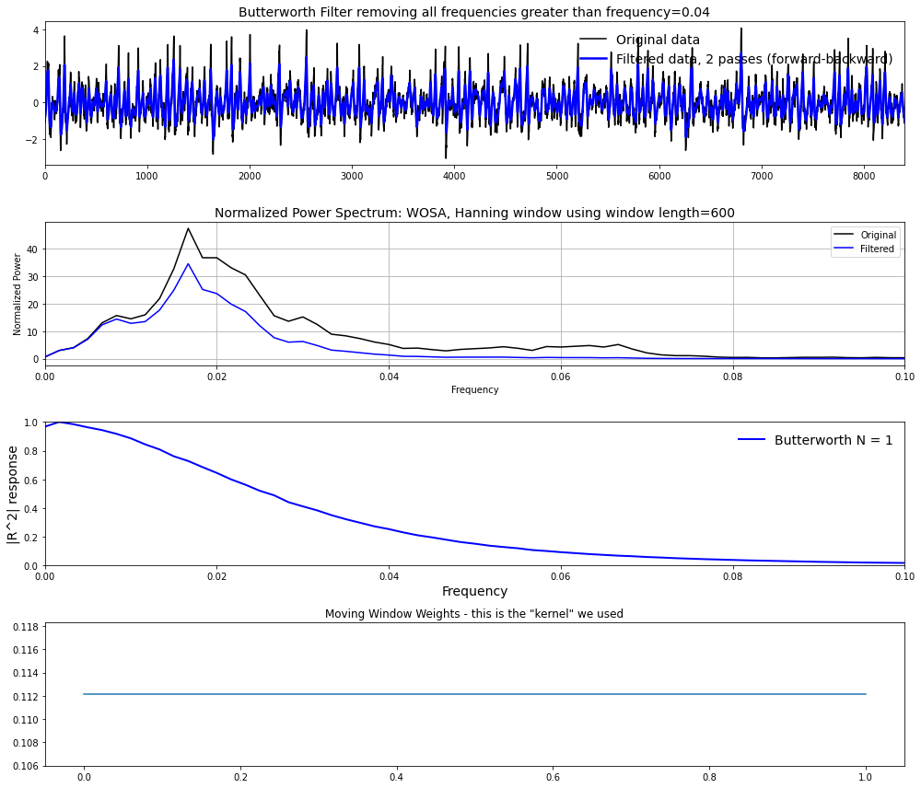
Removing frequencies greater than 0.04, not much changes because there isn’t much power above a frequency of 0.04. As a result, the filtered timeseries looks very similar to the original data, but some of the peaks appear reduced. Therefore, in the time domain, not much has changed. In the spatial dimension, the normalized power goes flat at 0.04, which is expected because we removed these frequencies using the Butterworth filter. This is also reflected in the response curve because we see that at a frequency of 0, we see only a slight change in the power spectrum. This decreases with frequency.

4) Let’s apply another Butterworth Filter and this time really get rid of ENSO power!. Let’s really have some fun with the Butterworth filter and have a big impact on our data... Let’s remove ENSO variability from our original timeseries. Apply the Butterworth filter but this time change the frequency that you are cutting off to 0.01 per month (i.e., remove all power with timescales less than 8 years). Use an order 1 filter (N=1). Replot the original data and the filtered data. Calculate the power spectra of your filtered data. Assess the influence of your filtering in both in time domain (i.e., by comparing the original data time series and filtered time series data) and the frequency domain (i.e., by comparing the power spectrum of the original data and the power spectrum of the filtered data). Look at the response function of the filter in spectral domain using the convolution theorem.

5) Let’s apply yet another Butterworth Filter – and this time one with more weights. Repeat step 4) but this time change the order of the filter. In other words, increase the number of weights being used in the filter by increasing the parameter N in the jupyter notebook. What is the impact of increasing N on the filtered dataset, the power spectra, and the moving window weights? You should see that as you increase N – a sharper cutoff in frequency space occurs in the power spectra. Why?
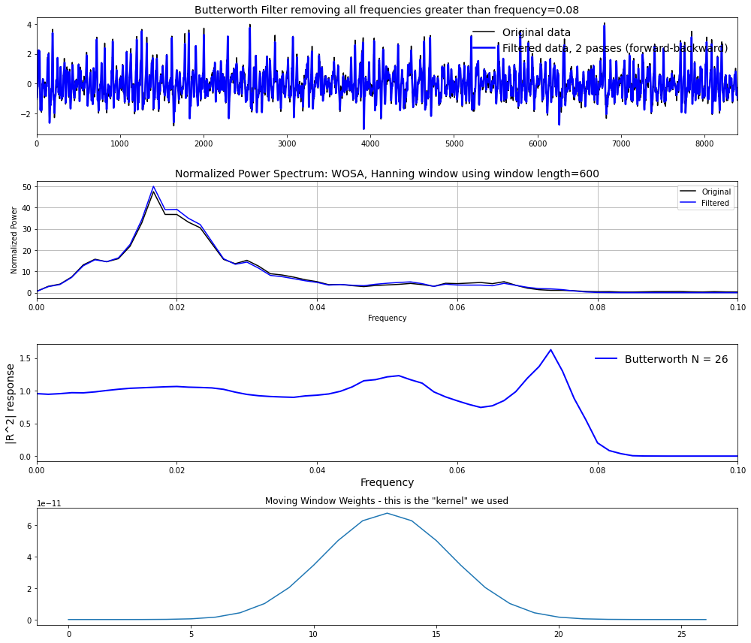
The number of weights was increased to 26. As you increase N, there becomes a sharper cutoff in the response function because the response of the function is felt over more time steps. Therefore, by increasing N, it takes more time for the influence of a data point to die away. When changing the weights from 20 to 25, we see a response function that becomes closer to a boxcar but goes a bit crazy when it reaches N=26. At this, we start to see some sinusoidal responses with a sharp decrease. At N=26, the power still looks relatively correct, but when N=27, the power is moved and the response function is no longer an appropriate filter because we’ve messed too much with the data. At N=27, the response function takes on a sinusoidal shape and we start to really see the impacts of the impulse function. Because increasing N approaches a Boxcar window, it doesn’t take as long for the response function to change and we therefore can keep more power where we aren’t trying to remove it.

6) Assess what is “under the hood” of the python function. How are the edge effects treated? Why is the function filtfilt filtering twice?
The function filtfilt is one way of treating edge effects. It filters twice because we’re using a moving window weight as we want to make use of as much data as we can. Because a forward filter doesn’t make use of the beginning data and a backward filter doesn’t make use of the last data, filtering both ways give us a zero phase and a filter order twice that of the original.

